**Dynamic Styling**

**What is dynamic styling?**

= When styling for a specific html tag under a condition then it is called dynamic styling.

**How we can do Dynamic Styling?**

= 1st create a js file named dynamicStyling.js and a css file named dynamicStyle.css

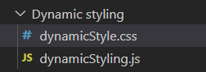

In the js file,

import React, { useState } from 'react'

import "./dynamicStyle.css"

export default function Dynamic_Styling() {

Set the initial value for style as false

  const [style, setstyle] = useState(false);

  let handleChange=(e)=>{

      let txt=e.target.value

      if(txt.length<2)

Create a handleChange function to create a condition that is when the input value’s length is greater then 2 then setstyle(true)

      {

        setstyle(false)

      }

      else{

        setstyle(true)

      }

  }

  return (

create a classname with the condition of style. If the style is true then valid is applied and If the style is not true then invalid is applied

    <div>

      <br /><br />

      <hr /><hr />

  <input type="text" onChange={handleChange} className={`${style?"valid" : "invalid"}`} />

    </div>

  )

}

In the css file,

.valid{

    background-color: rgb(171, 230, 210);

    font-style: italic;

}

.invalid{

    background-color: rgb(204, 164, 242);

}

Output:

Normally,

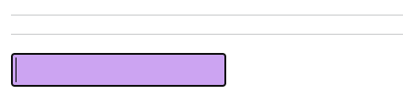

When we type 2 or more letter

